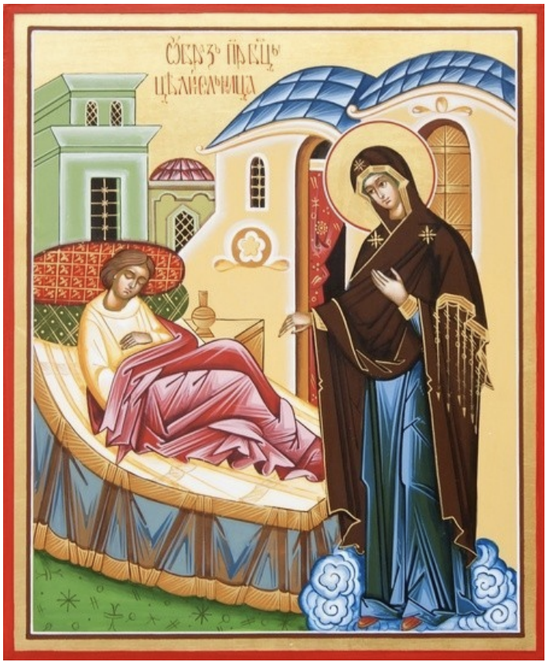

Akathist to the Blessed Virgin Mary  
 in front of Her icon, called   
The Healer

Kondak

Selected from all clans of the Blessed Virgin Mary, who sometimes appeared to a clergyman who is sick in a hedgehog, heal him of a fierce, laudable disease, we bring songs: You are the All-Merciful Lady, who has an invincible power, from all troubles and sorrows and illnesses of the free One who is blessed, Hail Rejoice, Hail , soul and body of ours.

Ikos 1

Archangel Gabriel, proclaiming to the Most Holy Virgin Mary the seedless conception from Ney the Son of God, speech: Rejoice; Gracious, the Lord is with you, Blessed are you in women, but we imitate sinning the voice of the Archangel, daring with faith and love, reverential cry of a singing song: Rejoice, from the beginning of the centuries, chosen for the head of our salvation; Rejoice, manifold from the prophets, foreshadowed. Rejoice, Bride of the Shameful, conceived of the Son from the Holy Spirit; Rejoice, Mato in Christmas, and after Christmas Devo. Rejoice, who clothed her with light like a robe of swaddling clothes, rejoice, feeding the miner's grace and dolly grace with my milk, nourishing her grace. Rejoice, having carried the Almighty on thy hand; Rejoice, O caregiver of all creatures who had a care. Rejoice, most exalted of Him, rejoice, most honest and glorious without comparing all the heavenly forces. Rejoice, Gracious Healer, our souls and our bodies.

Kondak 2

Seeing the Most Holy Lady, the ardent and reverent clergy of Vincent, bowing knees before the honest one every day, and the Archangel salute to the one who brings you, received such a favor and gave him a sudden and wondrous rebellion in the days of illness. By the same token, we kneel our souls and bodies before Your Lady of Celibacy, Our Lady, and commemorating the miraculous appearance of a sick cleric, a cry to Your Son and our God: Hallelujah.

Ikos 2

Having understood the miraculous healing from a serious illness, the clergyman Vincent, having risen from his wretched bed, went to church and there with songs of praise glorify the Healer of all who are sick, accept the Mother of God from us, these blessings: Rejoice, from the gate of the mortals who are painlessly ill, bringing you back to life; Rejoice, full of compassion for the afflicted. Rejoice, stricken with various ailments, wonderfully healing; Rejoice, in all sorrow and sorrow the heavenly joy in our hearts is pouring out. Rejoice, inspiring us with love for God and our neighbors; Rejoice, from the corruption of this world that corrupts the soul and body. Rejoice, ambulance listener diligently for the prayers of you; Rejoice, exuding great mercy and generosity to those who love Thee. Rejoice, who trusting in Thee, all that is needed in the stomach, this giver; Rejoice, thou who didn’t leave them at the formidable hour of death. Rejoice, Gracious Healer, our souls and our bodies.

Kondak 3

By the power of thee from You, Madame Tsaritsa and Mistress, Your Holy Icon exudes earnestly healing the afflicted from afflictions of various kinds and invisible to those who come to Her, crying out to God: Alleluia.

Ikos 3

Those who have much love for the Christian family and motherier care for it to all who ask for your help and intercession, all good petitions will soon be fulfilled; Therefore, for the sake of you, the Almighty Intercessor and our first helper, we bring this praise: Rejoice, mourners of comfort; Rejoice, hopeless hope. Rejoice, laboring help and strengthening; Rejoice, beggars of the robe. Rejoice, hungry nourishment; Rejoice, offended and persecuted intercession. Rejoice, those who offend the intimidator; Rejoice, mentor in the Christian faith. Rejoice, recovery of the dead; Rejoice, companion of the salvation of sinners. Rejoice, powerful defenses against crafty demons. Rejoice, Gracious Healer, our souls and our bodies.

Kondak 4

Storm the passions and lusts of the temptations of demons, deliver us, the Most Compassionate Mother of God, strengthen and preserve in us until the end of our life our Orthodox faith and devotion to the holy Church, let it be unselected to the Lord God: Alleluia.

Ikos 4

Hearing the Lord in thy heaven praying for us, Proclaiming to the Mistress, she soon fulfills all your petitions, conducts such swearing boldness to your son Jesus Christ, we all resort to you and earnestly pray to you, stand for us, your sinful servants, before our Almighty Creator, May he not destroy us with our iniquities, but may He give us the forgiveness of sins crying out to you from the bottom of our hearts: Rejoice, salvation before God, who saves the world from misfortunes; Rejoice, thou who declareth thy Son not merciful unto us unto us. Rejoice, thou who delivereth from the burning of the fiery dew of thy prayers; Rejoice, thrusts of lightning and thunder from our head. Rejoice, deceiving the holy foolish wisdom of this world; Rejoice, showing the ways of salvation to the lost. Rejoice, one who grants boldness to God as a sinner; Rejoice, who is exhausted in adversity, sorrow and temptations. Helping soon. Rejoice, in fasting and prayer and Divine Thought for those who are abiding, he who is ever so demanding; Rejoice, blessed earthly, vain and soon passing teaches us to despise.

Rejoice, unto our heavenly and eternal treasures of the minds and hearts of our hearers. Rejoice, Gracious Healer, our souls and our bodies.

Kondak 5

Light of the heavenly illumination The temple of the ill cleric has always appeared before you. Offering to the Lady, grant him healing from a fierce ailment. Oh, Most Holy Lady of the Virgin, enlighten our souls darkened by many sins and suppress healing by our sick body, and glorify Your mercy with a cry of joy to God: Hallelujah.

Ikos 5

Seeing Your Lady the Mother of God before the fire-throne of the Most Holy Trinity I am standing and praying for Christians, heavenly powers and all the blessings from the ages of God pleasing God with silent blessings please Th. But we sin against the earth to love you, we dare to chant to you: Rejoice, swearing love through the swearing love of the whole Christian world; Rejoice, all faithful good Intercessor.

Rejoice, consummate henchman leading the battle against the temptations of the worldly and the harmful; Rejoice, from all wickedness and enmity, protecting the world and love. Rejoice, all that have come running under thy shelter, Rejoice, master of chastity and temperance. Rejoice, devotees of piety to the high Jerusalem Guidebook; Rejoice, destructive heresies and schisms to the eradicator. Rejoice, bearer of soulful knowledge; Rejoice, ambulance in troubles and sorrows. Rejoice, Our Prayer Book before Your Son and God. Rejoice, Gracious Healer, our souls and our bodies.

Kondak 6

Preached by the saint [Orthodox Church](https://enderdest.ru/en/what-is-the-day-of-the-angel-of-man-day-of-the-angel-in-the-orthodox-church.html) many miracles of Your greatness of Thy mercy, Proclaiming to the mistress, as you protect the city and monastery, the monastery of monk and the dwelling place of pious slaves, protect those who are offended to stand up, and all the good and soulful send down to all who glorify Thee and sing to Your Son: Allah.

Ikos 6

The Lady of the Virgin flaunts light here, Your miraculous icon called the “Healer,” chasing away from all faithful the darkness of temptations and tricks and abundantly exuding healing. For this reason, in tenderness, we call Ti: Rejoice, for healer that gives healing from incurable diseases; Rejoice, for deliverance from all troubles and sorrows. Rejoice, sinning passions Taming, rejoice, strengthening in the faith of the Orthodox Orthodox. Rejoice, gracious consolation pouring out in the hearts of the God-loving; Rejoice, delighting soul of the hope of heavenly goods of the faithful. Rejoice, in helping us to succeed in good deeds; Rejoice, from the visible and invisible enemy protecting us. Rejoice, rebuilding by the grace of Your grace of the fallen; Rejoice, the fear of God in our hearts inspires. Rejoice, all our good petition is soon fulfilling. Rejoice, Gracious Healer, our souls and our bodies.

Kondak 7

Those who want to show Your mercy, inexpressible granted to us, Offering to the Virgin Virgin, Your miraculous icon called the “Healer”, and all those who flow to Her with faith from faith are freed and are given every comfort, for the sake of crying out to God for you; Hallelujah.

Ikos 7

It’s marvelous and glorious is Your deeds, the Immaculate Lady, to all who are rich and poor, healthy and sick, and with diligent prayer before the Icon of Christ that blesses you, I flow all that is good for every need and to the extent of faith and love you give, and we don’t conceal Your good deeds, but thankfully glorifying Your mercies with the verb Tiice: Rejoice, deaf hearing; Rejoice, blind enlightenment. Rejoice, dumb verbalization; Rejoice, lame walk. Rejoice, lepers of purification; Rejoice, relaxed strengthening. Rejoice, freedom from evil and evil spirits; Rejoice, according to Bose, our refuge and intercession. Rejoice, from needs, and sorrows, and troubles, an indispensable deliverance; Rejoice, addiction to perishable wealth. Rejoice, seek to teach the wealth imperishable in heaven. Rejoice, Gracious Healer, our souls and our bodies.

Kondak 8

Wanderers and aliens in this world of sorrow and multitude, of the everlasting heavenly fatherland, we seek out the almighty Queen Empress, the Virgin Mary, humbly ask, guide us along the paths of the saving commandments of Your Son, Christ our God, let us not be unharmed.

Ikos 8

The whole Christian world pleases Thou the Immaculate Virgin with the voices of praise to all faithful, but the most painful is comforting to look at your venerable icon “The Healer” called. Oh, the Blessed Lady of the Virgin, accept and our tender praise is such; Rejoice, our joy; Rejoice, untold kindness. Rejoice, highness of virtues; Rejoice deeply in humility. Rejoice, inexhaustible source of mercies and generosity, rejoice, fragrant color of Virginity and purity. Rejoice, faith of the Christian statement; Rejoice, ungodliness of reproof. Rejoice, praise of the mountains; Rejoice at all the righteous glories. Rejoice, Gracious Healer, our souls and our bodies.

Kondak 9

We lay all our hope in The Mother of God and, in secret and ill, to Your holy icon, we flow with reverence and faith. More often, Ney will soon receive comfort and healing. O Most Holy Queen of the Virgin Mary, graciously look at your humble servants and expedite the fulfillment of all that is of benefit to us in this life and in the future. Let us praise the Creator God, glorifying Your goodness: Alleluia.

Ikos 9

The veterans of multicasting will not be able to adequately praise Ty, the Most Pure Virgin, the Most Honorable Cherub and the Most Glorious, without comparison, Seraphim, who has given birth to the Savior of our souls without a trace. We, however, are weak and weak, we conquer love for You, we open our unworthy lips to your praise. Your back: Rejoice. miracles of Christ beginning; rejoice. the fulfillment of all prophecies. Rejoice, having transcended the purity of the Angels; Rejoice, virginity and Christmas combined wonderfully in yourself. Rejoice, in both immaculate and holy unto yourself, rejoice, mother of the Son of God and the Most High God. Rejoice, for fallen humanity, having opened the entrance to the kingdom of heaven; Rejoice, quiet refuge from the storms floating on the sea of \u200b\u200blife. Rejoice, God bestowed joy upon the afflicted; Rejoice in the radiant grace and glory of the prior knowledge and miracles. Rejoice, Gracious Healer, our souls and our bodies.

Kondak 10

Although the whole human race is to be saved from lawlessness and eternal torment, the Lover of God is a Mother of God who gives His gift to help, cover and protect those who believe in Him, glorifying such mercy for us sinners with a thankful heart and verbal cry to Him: Alleluia.

Ikos 10

Thou art unbroken wall and strong intercession, Our Lady of the Virgin, all who have recourse to you with prayer. With the same slaughter and us unworthy fences from fierce illnesses and from every evil spite of the situation, and in all cases dealt with the timely help and strengthening of those who call upon T: Rejoice, our Patroness has also been praised; Rejoice, guardian of ours and affirmation. Rejoice, Our joy and our care for us; Rejoice, our famous refuge in all mournful situations. Rejoice, upbringing of the babies: Rejoice, young chastity mentor. Rejoice, spouse giving love and consent; Rejoice, reverent old men leading to the peaceful demise of life. Rejoice, faithful shepherds of the Holy Church strengthening and admonishing; Rejoice, in a monastic manner, as you work for the intercessor of eternal joy. Rejoice, in the world of godly living, not delivering by His intercession. Rejoice, thirsty Healer, souls and bodies of ours.

Kondak 11

Singing and prayers of our all-merciful brought before the celibate Thy way, receive the Virgin Mary, and you may sing to the One God until the end of our life: Alleluia.

Ikos 11

Your miracle-working icon, the Mother of God, shines with light of light, exuding faithful currents of healing of grace, instructing those who wander in the darkness of sins on the bright path of virtues and salvation. For this, for the cry of Tee, the laudatory song is as follows: Rejoice, in the fall of Thy icon throws away the power of hostility from all; Rejoice, all who have resorted to sorrow, needs, and sicknesses will soon be comforting and giving healing. Rejoice, miracle of miracles, Hodegetria to the Lady, instructing on the way of salvation, rejoice, peaceable dispensation granting the overwhelmed misfortune. Rejoice, in the purity of Thy purity of life that teaches us; Rejoice, cunning, proud, and angry people. Rejoice, inspiring the righteous faith and fear of God in us; Rejoice, through the light of Christ’s doctrine, the darkness of unbelief is banishing. Rejoice, confusion of the thoughts of the mundane deletes; Rejoice, generous Giver of all spiritual gifts. Rejoice, Gracious Healer, our souls and our bodies.

Kondak 12

Grace and Your bounties, the Most Compassionate Lady, do not leave the Orthodox Christians, giving consolation to those who mourn, offending intercession, those who are sick and all who are in troubles of various kinds of deliverance, for this glorifying You thankfully cry to God: Alleluia.

Ikos 12

It is Thy singing of your indescribable mercies and miracles that are unworthy of us, we bow our knees to the Holy God-bearing image, Our Lady of the Virgin, we pray Thou earnestly, give us peace, silence and good death, and do not leave Your help and intercession in the Second Coming of Your Son and our God, Ty with tenderness this praise: Rejoice, in the despondency and despair of those who fell, strengthens with the hope of salvation; Rejoice, resolving sinful bond. Rejoice, righteous wrath of God upon us, offering mercy; Rejoice, arranging our good life on earth. Rejoice, who is delivering us from dangerous situations; Rejoice, at the hour of death, to all the faithful, an ambulance to the Assistant. Rejoice, reverers of thee at the ordeals of the air interceding; Rejoice, love for thee who has the gates of paradise, which opens. Rejoice, glorifying those who bless you with everlasting bliss in the kingdom of heaven, rejoice, rejoicing those who do not honor you before all the shame. Rejoice, our sovereign ambulance in the days of severe trials. Rejoice, Gracious Healer, our souls and our bodies.

Kondak 13

O All-Mother of Our Sweetest Lord Jesus Christ, graciously accept this little prayer of ours, save us from all misfortune, disease and sudden death, and make us heirs of the being of the Kingdom of Heaven and with all saints sing to Your Son and our God: Hallelujah.

*(This kondak is read three times, then icos 1 and kondak 1)*

Prayer before the Icon of the Mother of God “Healer”.

Accept, O All-Blessed and Almighty Lady of the Virgin Mary, the Virgin, this prayer, with tears to You, brought from us, unworthy Thy servants, singing to Your celibate image with tenderness, as It is to You Ourselves and receiving our prayers. By no means do you ask for the fulfillment of your deeds, your sorrows lighten up, the weak health of the daries, the weak and ill-cured, heal, you drive away demons, who are offended by misfortunes, you rid yourself of lepers, and you merciless little children, and you are more blessed to be the Lord and Lady of God. and all the various passions of the doctor: the whole essence is possible by Your intercession to Your Son, Christ our God. O All-Mother, Mother of God! Do not stop praying for us, unworthy Thy servants, glorifying Thy and worshiping Thy, and worshiping with tenderness Your Most Holy Image, and those who have hope will not return and faith unshakable to You, Most Holy Virgin and Immaculate, now and ever and ever Amin.

The Troparion to the Blessed Virgin Mary in front of Her icon called the “Healer”

Troparion, voice 4

Like the Most Holy Star, blessed with holy Divine miracles Your image as the “Healer”, submit to us, the Virgin Mary, the healing of mental and physical ailments, salvation and great mercy.

Troparion, voice 1

To Love, the Pure Virgin, Your holy icon to those who revere and to God Your true Mother who glorifies and faithfully worships, the Healer come forth, removing all evil and disease from them, like the Almighty.